Abstrat:- A new approach to image retrieval is presented in the domain of museum and gallery image collections. Specialist algorithms, developed to address specific retrieval tasks, are combined with more conventional content and metadata retrieval approaches, and implemented within a distributed architecture to provide cross-collection searching and navigation in a seamless way. External systems can access the different collections using interoperability protocols and open standards, which were extended to accommodate content based as well as text based retrieval paradigms. After a brief overview of the complete system, we describe the novel design and evaluation of some of the specialist image analysis algorithms including a method for image retrieval based on sub-image queries, retrievals based on very low quality images and retrieval using canvas crack patterns. We show how effective retrieval results can be achieved by real end-users consisting of major museums and galleries, accessing the distributed but integrated digital collections.
An Integrated Content and Metadata based Retrieval System for Art
P.H.Lewis, K.Martinez, F.S.Abas, M.F.A.Fauzi, S.C.Y.Chan, M.Addis, C.Lahanier, J.Stevenson

Index Terms— Content based image retrieval, art images, wavelets, crack analysis

I INTRODUCTION

Content based image retrieval from large digital collections has continued to challenge the image processing and computer vision communities in-spite of substantial research efforts in the area in the last ten to fifteen years[9] [23] [28]. Although content-based techniques offered, and continue to offer, the possibility of alleviating, if not overcoming, the problem of labour intensive keyword classification, their promise remains largely unrealised and commercial content based image retrieval systems have so far failed to achieve significant commercial success[24]. General approaches based mainly around colour and texture feature extraction are still being refined [25] [26], while current shape based retrieval is only useful in rather limited domains[27].

The need for effective image retrieval facilities continues to increase as digital libraries, personal image capture systems and the applications of imaging in science and medicine all expand rapidly. The problem of image retrieval on the web is a related challenge and it is interesting to note that here too the approach has been to rely mainly on associated text and metadata. Most commercial users of image collections also continue to use metadata for general purpose retrieval tasks and the semantic gap is identified as the main culprit in the field [29]. Some of the most promising work attempting to overcome the problem is concerned with automating the building of associations between image features and semantic concepts [30] [31]. However, such research is in its infancy and does not offer viable solutions for real applications in the immediate future. Various commercial and close to commercial experimental research systems have appeared such as QBIC[37], Virage [32], Netra[33], VisualSEEK[34], Mars[35], Photobook[36] and many others offering a variety of techniques and user interfaces for content-based retrieval, but none of these is seen as the panacea for all image database problems.

This paper is concerned with the problem of delivering effective integrated content and metadata based image retrieval across disparate image databases for several major museums and galleries across Europe. Even when textual metadata is available, problems of incompatibility between metadata schema can make cross-collection searching problematic. Prior to this work, access from one gallery system to another was not common even when using only textual data and it was not undertaken at all for cross-collection content based retrieval. However, the value of cross-collection searching was seen as a highly desirable objective, not only between museums, but between multiple databases within a single museum. In this paper we show how several novel and specific content-based techniques combined with general content-based techniques and a novel approach to interoperability can make cross-collection content and metadata based searching an effective approach for real end-users. The work formed part of an EU funded project called ARTISTE.

Content-based retrieval (CBR) of art images has been a particular challenge [1]–[3] as the image content covers a vast range of subjects and requirements from end-users are often very loosely defined. “Traditional” content based image retrieval algorithms have typically been applied with only limited success. In our approach we have augmented these traditional content-based retrieval algorithms with algorithms targeted at specific retrieval tasks identified as a high priority for the museums. We have also addressed the need for seamless cross-collection metadata based searching which can be applied either separately or in combination with the content based searching. Individual database schemas of the galleries are preserved and mapped to a common schema using RDF (Resource Description Framework) [4] and the distributed architecture not only preserves each gallery’s control over its own collection but accelerates and simplifies cross-collection searching in an integrated manner.

The next section gives a brief overview of the architecture developed to facilitate the distributed cross-collection searching and in the third section we describe the content based facilities implemented within the architecture. Particular attention is given to the novel special purpose algorithms introduced to provide sub-image matching and query by low quality image. The motivation for these algorithms and their evaluation are also presented in section 3. Real examples of combined and cross-collection searching are given in section 4 and conclusions and future work are presented in section 5.

II An Architecture For Cross Collection Searching
The ARTISTE architecture, developed to facilitate cross-collection content and metadata based searching, is illustrated schematically in Figure 1. Each participating museum has its own instantiation of the system and its images were held as binary large objects (BLOBS) in an object relational database management system (ORDBMS) from NCR, although this has since been replaced with mySQL [8]. The image processing functions were implemented as user defined modules (UDMs), which are executed within the database, minimising data transfers and facilitating use of the system’s parallelism [7]. Metadata is also stored in the database and complex queries, involving both image processing functions and metadata can be called directly from SQL.

Access to the system is achieved through standard web browsers, the pages being generated in the presentation layer using JSP (Java Server Pages) and Java Servlet technology. The distributed query layer, which is implemented as a web service using XML messaging and SOAP (Simple Object Access Protocol), provides a single interface to the disparate image and metadata collections and enables end users to seamlessly search individual or combined collections. Interoperability is usually achieved by using open standards, but as retrieval standards have been traditionally concerned with text based searching, we participated in an initiative[39] to redesign the open standard for interoperability between digital libraries, z39.50, using web technologies. The initiative proposed a Search and Retrieve Web Service (SRW) for searching databases containing metadata and objects and we extended the capabilities of SRW to enable both image content and metadata based search over multiple collections.

An image processing API was implemented to allow the Artiste Server to access the image processing functions within the ORDBMS. With over 2 Tbytes of images from the museums, scalability was a prime concern. Images accepted into the systems are analysed by the UDMs to produce feature vectors which are also stored as BLOBS within the database. During a query, these feature vectors are compared by fast operators which return scores. All the image processing code was written in C/C++ using the VIPS/ip library[6]. An administration interface also allowed new algorithms to be added to the system.

The syntax and semantics of standard metadata terms are defined using resource description format (RDF) [4] and mappings are provided from each collection. The mappings refer to common metadata schema such as Dublin Core[5] but are not limited to this. RDF schema is also used to describe image content as a metadata item. The operators (implemented using image processing algorithms.) relating to image content are explicitly defined along with the constraints under which these operators can be applied. For example, the multiscale colour coherence vector algorithm, MCCV, (see following section for details) implements a 'part of' operator which can be applied to an image to allow a sub-image to be found within it. The textual metadata equivalent would be to search within a string to find a key word. In this way it can be seen that a uniform approach is taken to the semantics of searching both textual content and image content.

The use of RDF provides a flexible solution to cross-collection searching. Mapping to common semantics requires no changes to local metadata and schemas. Multilingual translation of metadata attribute names allows the user to use their native language when specifying which attributes to search over for multiple collections. Finally, by publication of the RDF, a gallery can provide a machine readable description of any search and retrieval services it chooses to expose. This allows software clients to dynamically constrain the search facilities offered to users so that only the available query functionality is used.

III Content Based Image Retrieval

Many content-based image retrieval (CBR) systems work with whole images and address questions of the form “find me images similar to this query”. General techniques based on such features as colour distribution, texture, outline shape and spatial colour distribution have been popular in the research literature and in content based retrieval systems. Several extensive general reviews of content-based image retrieval techniques have appeared in recent years [9][23][28]. CBR has been applied to art images since the 1980s with the Morelli project [1] and IBM's QBIC for example has been applied to such images in collaboration with UC-Davis [2] Previous approaches usually applied a generic CBR system to a group of Art images to see how useful it would be. In Artiste, by contrast, our aim has been to augment these traditional CBR approaches with solutions to specific CBR problems by developing algorithms tailored to the tasks, rather than only producing generic solutions for all queries. Use of the colour histogram[10] for comparing images has been popular, primarily because it is easy to compute, is fairly insensitive to small variations between images and is relatively efficient in terms of computation speed and storage requirements. It has the disadvantage that it does not capture any information about the distribution of the colours spatially within the image and various techniques to capture such information have been proposed including the colour coherence vector approach [11] and the use of colour pairs [12].
In the Artiste system we began by introducing standard CBR algorithms for colour based retrieval based on histograms of various colour spaces (RGB, HSV, LUV), for texture based retrieval using the pyramid wavelet transform [38] and for spatial colour based retrieval using colour coherence vectors. Feature vectors for all these algorithms were pre-computed when the images entered the system and facilitated very general content based searching on a full image basis which could be combined with metadata based searching to effect retrieval. However, many techniques like these only work on the complete image, will not allow the query image to be a sub-image of the image to be retrieved and often require similarity in image resolution between query and target.
Sub-image matching
Our collaborating galleries had a specific requirement to be able to retrieve the full image of a painting, given a query image which is of a fragment of the full painting (i.e. a sub-image). The query may have been captured under different conditions and possibly at a different stage in the restoration process from the parent. If the connection between the parent painting and the fragment has been lost, the need for sub-image matching in order to re-identify the parent becomes clear, particularly as the collections contain large numbers of very high resolution images. Our approach to the sub-image problem has been to divide the database images into a pyramid of image patches, extracting feature vectors for each patch and matching the query feature vectors with each of the feature vectors from the database images to find the best match[13]. We have used a patch size of 64 by 64 pixels, a compromise reached by experimentation, and not only tile the whole image with such patches but also repeat the process with another set of patches offset horizontally by 32 from the first set, then offset vertically by 32 and finally offset both horizontally and vertically. The resolution of the image is then reduced by a factor of two and the process repeated recursively until the image is approximately covered by a single patch. In general, global techniques such as the colour histogram are not effective for sub-image matching in their basic form and previous workers have also used the hierarchy approach.

In our approach, for matching based on colour, we use the colour coherence vector (CCV) rather than the basic colour histogram used in earlier decompositions, as the representation of the individual image patches since it carries useful local spatial information. The colour coherence vector [11] records the numbers of coherent and incoherent pixels of each colour in the patch, where a coherent pixel is one which belongs to a region of similar coloured pixels whose relative size is above a certain threshold. The colour space is quantised into 64 cells. The CCVs are coded for rapid matching and could be compared at an average rate of 265,000 per second on a 600MHz Pentium III processor. In figure 2 we show a genuine museum query image which is a fragment of a painting captured before restoration work at the Louvre gallery. The best match is shown in the same figure and it can be seen that this is the correct parent image but after restoration. (The before restoration image was not in the database). Note that the position of the match is highlighted, a useful facility when dealing with small fragments from ultra high resolution images. This particular parent image is 6328 by 4712 pixels. It should be stressed that the parent image was scanned at 1.47 pixels per mm of the original painting whereas the sub-image query was captured at a quite different resolution, 0.92 pixels per mm. In this test there were over 1000 images in the database varying in size from 440,000 pixels to 30,000,000 pixels and the retrieval process took about 45.8 seconds on a Pentium III 600Mhz PC.
In order to evaluate the performance of the MCCV algorithm when sub-image quality is less than ideal we use the test database of 1000 images described above. Sets of query sub-images were selected at random from the test database and modified in a variety of ways and with varying strengths. Eight strength levels were used for each modification type. Since the sub-images used in the tests were taken directly from the parent, it was important to try and simulate the wide range of possible sub-image queries which could be submitted as a result of different image capture conditions, resolutions and image sizes. The three types of modification chosen to achieve this were:

- Blurring: which consisted of the application of a 3x3 averaging window, applied once for the first strength of blur, twice for the second and so on.

Noise addition: which consisted of adding Gaussian noise to the sub-images. The strength of the noise was determined by the standard deviation, sigma, of the Gaussian noise distribution. A strength of one corresponds to a sigma of one, a strength of two corresponds to a sigma of two and so on.
- Resizing: which consisted of reducing the size of query sub-images by a specified percentage determined by the strength. The strength of one corresponds to 0% reduction in image size, the strength of two corresponds to 10% reduction, the strength of three for a 30% reduction and so on.

The evaluation procedure was as follows:

Randomly select 100 images, I, from the database.
For each image in I randomly select a random sized sub image area and store in K
For all image operations, O (Blur, noise, sub-sample, identity)
For each image I_{n} in K
Apply image processing operation O to image I_{n} to produce image J.
Create MCCV feature vector F from image J.
Compare F with all feature vectors in database.
Order similarities and record rank information.

The graphs presented below are cumulative graphs of the retrieval results. They show the percentage of correct matches, across the tests, found within the top X hits where X is given by the within rank value on the x coordinate. The legends in the graphs show the strengths at which the algorithms were applied, where S1 is the weakest through to S8 the strongest. Note that for each query in these tests there is only one correct match so precision and recall metrics would be less useful in this context.

The first graph below shows the results when no corruption is applied to the sub-images. It can be seen that 88% of the tests gave the correct match as the best match found and 96% of the tests found the correct match in the top ten best matches. The Blur test shows that even with the highest strengths of blur, the correct matches are found above 90% of the time within the top 10 hits. The robustness to noise is less successful and the correct matches are found in the top 10 hits for only about 70% of the tests. Robustness to resizing is reasonable since, although only about 70% of the tests gave the correct match as the best match when applying the strongest resizing, it can be seen that at least 90% of the tests find the best match in the top ten for all strengths of resizing.

The multi-scale algorithm has been implemented in such a way that any appropriate algorithm applicable to whole images, may be used in a multi-scale version without further implementation. Thus, for example, our texture matching algorithm, based on the wavelet transform, is also used for sub-image matching when the required basis for sub-image matching is texture.
Query by Low Quality Image

One of the problems which galleries sometimes encounter is being asked “have you got this particular painting or art work in your collection?” when the image submitted as the basis for the query is a very poor and anonymous representation of the original. The image is typically monochrome, perhaps a photocopy of a book image, a fax of a postcard or some other low quality representation. The query images are essentially binary and the problem for query by example is that, in order to calculate the similarity to a database image, it is necessary to degrade the database image in a way which depends on the query so that pre-computation of the feature vectors is not straightforward.

Two approaches to the problem were developed. Both involve resizing the images to some standard. The first approach uses a pixel by pixel comparison, resulting in a very slow but relatively high accuracy retrieval. This method is referred to as the slow query by low-quality image (QBLI) method. It is used as a yardstick for comparison to a faster, wavelet-based algorithm. We call this wavelet-based method the fast QBLI method. It is a modification of the slow QBLI method and has the advantage of high retrieval accuracy while maintaining a low computational load. Throughout this section genuine fax images, received by galleries, are used as our query examples.

The Slow QBLI Method: The slow QBLI method is based on the fact that the low quality images are almost binary in nature. The query image is first converted to be totally binary, and the percentage of black (or white) pixels is computed. The image to be compared to the query is then converted to binary by thresholding the luminance in such a way that the percentage of its black (or white) pixels is similar to that in the binary query image. Both binary images are re-sampled to the same size 64 x 64 pixels) and a pixel by pixel comparison is made. The number of matching pixels, as a percentage of the total number of pixels, is used as the similarity measure and the database images are presented in decreasing order of similarity.

The slow QBLI algorithm is not ideal for interactive retrievals since it involves a high computational load. Using this algorithm, it is not possible to do any pre-computing without using large amounts of storage to hold multiple binary versions of each database image, corresponding to the range of possible thresholding values. For this reason, all calculations are performed during the retrieval process making this a slow but very accurate process for query by low quality images.

The Fast QBLI Method: For this method the Pyramid Wavelet Transform (PWT) coefficients [14] are used to compute the feature vector of an image. The reason for using the PWT is that, for a non-textured image, the frequency content is concentrated in the low frequency region, thus image decomposition is needed just for the low frequency band. Moreover, the PWT has a compact feature vector and a low computational load, which is essential for the retrieval algorithm.

Since the quality of the query images is so low that they differ substantially from their originals, applying the PWT to the original image will not produce a feature vector close enough to the feature vector from the query. As in the slow QBLI method, the query image is first converted to a binary image, before the PWT is applied. A similar conversion to binary is applied to each of the database images, choosing a threshold which makes them as close as possible (in terms of the proportions of black and white pixels) to the binary fax image, before the PWT is applied.

This method may seem to be unsuitable for interactive retrieval applications since it requires the feature vectors of the images in the database to be computed in advance. However, due to the compact nature of the wavelet signatures, it is possible to implement the algorithm in an effective manner. The algorithm consists of two steps; binary image creation and feature vector computation and comparison.

As stated earlier, since the query images are almost binary, it is better to compute feature vectors in the binary domain. The query image can be converted to binary by thresholding at the centre of the grey scale range covered by the image. In order for the feature vector of a database image to be compared fairly with the feature vectors from the query, the database image must also be converted to binary. But the choice of threshold is not immediately obvious. For the original database image corresponding to the query, an appropriate threshold is again chosen as the one that produces a binary image with the same percentage of black (or white) pixels as the binary form of the query image. This percentage could be used for all the database images, but it varies from query to query.

How can the percentage be matched if the feature vectors from the binary versions of all the database images are to be pre-computed? Note that since the query image is the target and already effectively binary, it is the database images that must be made as close as possible to the binary query and not vice versa. A solution to this problem is to convert each database image into a set of different binary images corresponding to different percentages of black pixels between 0 and 100%. If sufficient binaries are created, the binary query image will then be very similar to one of these binaries for the original image. Ninety nine binaries were created for each database image corresponding to percentages of black pixels from 1 to 99 in steps of 1%.

However, the binaries do not need to be stored. Calculating the feature vectors for the database involves calculating the PWT for each of the binary images for each image in the database. This is implementable since the PWT is a fast algorithm and, more importantly, the feature vectors for each binary image have only a relatively small number of coefficients. During matching, for each database image, only one of the sets of wavelet coefficients will be used in the comparison, namely the set associated with the same black pixel percentage as found in the binary query image.

Since the PWT can be applied only on dyadic square images, the binary images are all resized to 256 x 256. The resizing can also be done before the binary conversion. The PWT algorithm is applied and the image is decomposed into four sub-images ({LL, LH, HL and HH). The LL band is decomposed further until the smallest sub-images are of size 4 x 4, i.e. six levels of decomposition. This results in 19 different sub-images or sub-bands.

Once the wavelet coefficients of a binary image are available, features are computed from each sub-band, resulting in 19 features for each binary image. The mean μ is the energy measure used to compute the features. Let the image sub-band be W_{mn}(x,y) while mn denotes the specific sub-band, m is the decomposition level and n=1,2,3,4 indicates the LL, LH, HL, HH bands respectively, then μ_{mn} is calculated by:

$$μ=\frac{1}{N_{\text{mn}}^{2}}\iint{|W_{\text{mn}}}(x,y)|\text{dxdy}$$

where N is the length of a particular sub-band mn. The feature vector f, for a particular binary image is therefore:

$f=[μ_{\text{mn}}],n≠1$ except for the coarsest level, m=6.
$\overset{}{}=[μ_{1,2},μ_{1,3},μ_{1,4},μ_{2,2}\text{.}\text{.}\text{.}\text{.},μ_{6,1},μ_{6,2},μ_{6,3},μ_{6,4}]$

The feature vectors for the database images will have 99 x 19=1881 coefficients, although only 19 will be used for comparison in each retrieval task. The distance classifier used is the Euclidean minimum distance. The distance between 2 features, i and j, is given by:

$$d(i,j)=\sqrt{\sum{\sum{[μ_{\text{mn}}^{(i)}−μ_{\text{mn}}^{(j)}]\overset{2}{}}}}$$

Once the distances are computed, the images will be retrieved in order of increasing distance from the query image.

Experiments were conducted using as the query, each of the 20 genuine fax images with a range of qualities as the query, and a database consisting of 1058 images of various types and sizes, including the original images of the 20 fax images. The fax images and their originals are shown in figure 3. The evaluation is based on the ability of the algorithm to retrieve the original image when the fax version of the original is used as the query. The results for the fast QBLI algorithm in table 1 show the retrieval position of the original image among the 1058 database images, using Daubechies [15] family wavelets with 8 vanishing moments as the wavelet bases. Figure 4 shows an example of three retrieval results using the fast QBLI algorithm.

Table 1 also shows the results obtained by using a basic query by example retrieval with the same PWT features but calculated from the raw query and database images without the initial binarisation stage. These are the sort of results one might expect from a standard CBIR system without special algorithms for special cases. It can be seen that the basic query by example algorithm is particularly poor for these low quality queries, but the retrieval results obtained using the fast QBLI algorithm are very encouraging. All the original images are retrieved within the top 5. This is a good result considering the poor quality of some of the fax images. The results suggest that the distances between the fax images and their originals in our feature space are very close and should still produce good results for a larger image database. Different wavelet bases were also tested in this experiment, and it was found that the choice of wavelet base (Haar and Battle-Lemarie family [15] ) has little effect on retrieval result. However the Daubechies wavelet gives a slightly better result, probably because it is compactly supported in both the time and frequency domain.

 | Rank of Original
Query  Image No. | Basic PWT  Technique | Slow QBLI  Technique | Fast QBLI  Technique
1 | 104 | 1 | 1
2 | 369 | 1 | 1
3 | 15 | 1 | 1
4 | 21 | 1 | 3
5 | 272 | 1 | 1
6 | 130 | 1 | 1
7 | 258 | 1 | 1
8 | 2 | 1 | 3
9 | 502 | 1 | 1
10 | 302 | 20 | 2
11 | 603 | 1 | 1
12 | 299 | 1 | 1
13 | 60 | 1 | 1
14 | 495 | 1 | 4
15 | 500 | 1 | 2
16 | 339 | 1 | 1
17 | 15 | 1 | 2
18 | 264 | 1 | 4
19 | 1 | 1 | 1
20 | 1 | 1 | 1

Table 1: Retrieval Results using 20 fax images on a database of 1058 images

Table 1 also shows the results for the slow QBLI method. As expected, the slow QBLI algorithm gives very good retrieval results. All the originals were returned as the first match, except for one case only, which is because that particular fax image and its original were of different object-to-background ratio, hence resulting in rather dissimilar images after binarisation. Table 2 compares the average time taken for retrieving images from the database of 1058 images with the basic PWT algorithm and the slow and fast QBLI algorithms. The times are for a 700 MHz Xeon processor. From table 1 and table 2 it can be seen that the fast QBLI algorithm almost equals the slow QBLI method in terms of retrieval performance, but involves a much smaller computational load.

It is also important to note that the PWT algorithm applied on binary images helps to minimise computation time. To sum up, it can be said that the fast QBLI method integrates the high accuracy of the slow QBLI method with the low computational load of the basic PWT method giving an effective approach to query with low quality example.

The two approaches to query by low-quality image give very good retrieval accuracy, although the speed of the fast QBLI method makes it much more suitable for interactive use. The fast QBLI method illustrates the importance of the wavelet-based feature extractor in this application, where in PWT, we have a very fast algorithm and compact feature vectors. These two constraints are important in using the fast QBLI method where multiple feature extractions as well as multiple feature vectors are necessary for each database image. Other feature extraction techniques are either slow or have large feature vectors.

Time Taken  To Retrieve Images  (in seconds) | Basic PWT | Slow QBLI | Fast QBLI
Time Taken  To Retrieve Images  (in seconds) | 1 | 130 | 1

Table 2: Comparison of computation times between the three algorithms

Another important observation from this part of the project is that although we used fax images in the evaluation, the method proposed is an excellent way to search using low quality images in general. This is shown by the fact that the basic PWT technique gives very poor retrieval accuracy when used in this kind of problem and suggests that other standard feature extraction methods will also fail to deliver a good performance if not accompanied by a tailored pre-processing stage.

Comments

These two retrieval algorithms are examples of the way in which the general purpose CBR facilities were augmented with tools for specific retrieval tasks. Other special purpose facilities are also being developed, some of which are concerned specifically with the paint crack patterns (craquelure) which can occur in paintings and which are of particular interest for conservation and monitoring. In this context, a new algorithm has been developed [16] in order to process two unusual query types: “find images with cracks like this image” and “find images with this class of cracks”. The overall goal was to analyse sub-regions of the images in order to classify the cracks (called craquelure) in the paint layer into one of a few classes [17]. Example classes are shown in figure 5.

We used a morphological top-hat operator [16] and adaptive grid-based thresholding [20] to detect the cracks. After thinning, the cracks are represented as chain code [21] and statistics gathered on the crack segments. These include lengths, straight line to actual length ratio (LTRL), directionality and orientation histogram [22].

Figure 6 illustrates the result of a fuzzy k-means clustering of two of these features. Cluster FKM2 represents cracks which are very directional and straight for example. By combining cluster scores for all the features a crack type score can be obtained. The issue of scale is complex because an area of cracks can cover very large areas of an image. Further details of this aspect of the work can be found in [22].

iv An example of Cross Collection Searching
In section 2 above we described how the integrated approach to cross-collection searching has been implemented and in the previous section we concentrated on a description and evaluation of two of the novel CBR algorithms. In this section we show by example how seamless access to the multiple distributed collections is achieved. Figure 7 shows a query combining image content and metadata searching across the Victoria and Albert Museum collection. The query uses the MCCV algorithm to find larger images, labelled as ‘Photograph’ and containing the specified query as a sub-image. The results, in figure 8, show that the system finds the photograph containing the query image as well as other photographs containing similar features and colours.

In figure 9 the results of a second query are shown. Three collections were specified to be searched and metadata values were selected from a list showing only those terms which can be mapped to fields in each of the selected collections. The unified results contain images returned from each of the selected collections.

VI CONCLUSIONS AND FUTURE WORK
In this paper we have presented a system for seamless cross-collection content and metadata based searching of museum image collections. The development and use of new and emerging standards have provided an effective approach to interoperability. Novel special purpose algorithms developed for handling particular aspects of art image retrieval have been described and evaluated. It has been shown that the multi-scale colour coherence vector (MCCV) technique can provide effective sub-image retrieval and is also applicable when the sub-mage and target are captured at different resolutions. The wavelet transform has formed the basis for a facility for query by fax and by other low quality images, and work has been presented on query by crack type. These, and other specialist algorithms, combined with more traditional content and metadata based facilities have been integrated into an effective framework for cross-collection searching.
The work of the Artiste project is being continued under a further European Project, Sculpteur, in which the database is being extended to hold 3D models of museum artefacts and the system is being integrated with emerging semantic web technology to enrich the knowledge base on the collections from the museums and galleries.
Acknowledgments
The authors are grateful to the European Commission for their support through grants IST-1999-11978 and IST-2001-35372 and to their collaborators on the ARTISTE project (NCR (Dk), Giunti Interactive Labs (I), Uffizi Gallery (I), The National Gallery (UK), C2RMF (FR), and the Victoria & Albert Museum (UK)) for image data and useful conversations. We also thank Dr Spike Bucklow (Hamilton-Kerr Institute Cambridge) for collaboration on craquelure types and Hewlett Packard for invaluable sponsorship under their Art & Science programme.

References

[1] W. Vaughan, “Automated Picture referencing; Another look at Morelli,” Computers and the History of Art, Harwood Academic Publishers, vol. 2, no. 2, 1991, pp.7-18.
[2] B. Holt and K. Weiss, “The QBIC Project in the Department of Art and Art History at UC Davis”. In The 60th ASIS Annual Meeting 1997, Digital Collections: Implications for users, funders, developers and maintainers, vol. 34, ASIS, 1997, pp 189-195.
[3] A. Del-Bimbo, M. Mugnaini, P. Pala and F. Turco, “Visual querying by color perceptive regions”, Pattern Recognition, vol. 31, no. 9, 1998, pp 1241-1253.
[4] RDF Resource Description Framework http://www.w3.org/RDF/
[5] DublinCore metadata initiative http://www.dublincore.org/
[6] J. Cupitt and K. Martinez, “VIPS: an image processing system for large images”, Proc. SPIE conference on Imaging Science and Technology, San Jose, vol. 2663, 1996, pp 19-28.
[7] P. Allen and M. Boniface and P. Lewis and K. Martinez, “Interoperability between Multimedia Collections for Content and Metadata-Based Searching”, Online Proceedings of the World Wide Web conference, Hawaii 2002, available: http://www2002.org/CDROM/alternate/196/index.html.
[8] MySQL: http://www.mysql.com.
[9] A. W. M. Smeulders, M. Worring, S. Santini, A. Gupta, and R. Jain, “Content-Based Image Retrieval at the End of the Early Years,” IEEE Trans. On Pattern Analysis And Machine Intelligence, vol. 22, pp, December 2000, 1349-1380
[10] M. J. Swain and D. H. Ballard. “Color Indexing “, International Journal of Computer Vision, vol. 7, no. 1, 1991. pp 11-32
[11] G. Pass, R. Zabih, and J. Miller. “Comparing Images Using Color Coherence Vectors”, Proceedings of ACM Multimedia, 1996. pp 65-73
[12] M. Westmacott, P. Lewis, K. Martinez, “Using colour pair patches for image retrieval”, Proceedings of the IS&T First European Conference on Colour in Graphics, Imaging and Vision, April 2002, pp. 245-247.
[13] S. Chan, K. Martinez, P. Lewis, C. Lahanier and J. Stevenson, “Handling Sub-Image Queries in Content-Based Retrieval of High Resolution Art Images”, Proc. International Cultural Heritage Informatics Meeting, vol. 2, Sept. 2001, pp.157-163.
[14] S. G. Mallat, “A theory for multiresolution signal decomposition: The Wavelet Representation,” IEEE Trans. on Pattern Analysis and Machine Intelligence, Vol.11, July 1989 pp. 674-693
[15] Wavelab Toolbox ver 802 for Matlab, available: http://www-stat.stanford.edu/wavelab/
[16] F. S. Abas and K. Martinez, “Classification of painting cracks for content-based analysis”, Proc. SPIE conference on Machine Vision Applications in Industrial Inspection XI, Jan 2003.
[17] S. Bucklow, “A Stylometric Analysis of Craquelure”, Computers and Humanities, vol. 31, 1989, pp. 503-521.
[18] F. Meyer, “Iterative Image Transformations for an Automatic Screening of Cervical Smears”, J.Histoch. Cytochem, vol. 27, 1979.
[19] I. Giakoumis, I. Pitas, “Digital Restoration of Painting Cracks”, in ISCAS '98, Proceedings of the IEEE International Symposium on Circuits and Signals, 31 May-3, June 1998, pp. 269-272.
[20] N. Otsu, “A Threshold Selection Method From Gray-level Histogram”, IEEE Trans. on Systems, Man, Cybernetics, vol. 9, no. 1, 1979, pp. 62-69.
[21] H. Freeman, “Boundary Encoding and Processing”, Picture Processing and Psychopictories, Academic Press, 1970.
[22] F. S. Abas and K. Martinez, “Craquelure Analysis for Content-Based Retrieval”, Proc. IEEE14th International Conference on Digital Signal Processing, July 2002, pp.111-114.
[23] Y. Rui, T.S.Huang and S.-F. Chang, “Image Retrieval ;Current Techniques, Promising Directions, and Open Issues” , Journal of Visual Communication and Image representation 10, (1999) 39-62
[24] J. P. Eakins, “Content Based Image Retrieval: What’s Holding it Back “, Paper given at the ASCI(Advanced Summer School for Computing and Imaging) 2002, Conference, Lochem, The Netherlands, June 19-21,2002.
[25] G. Qui, “Colour Image Indexing Using BTC”, IEEE Trans on Image Processing, vol 12 no 1, 2003, 93-101
[26] B. Zhu, M. Ramsey, H.Chen, “Creating a Large Scale Content-Based Airphoto Image Digital Library”,
IEEE Trans Image Processing vol 9, no 1, 2003, 163-167
[27] N. Arica, F.T Yarman-Viral, “A Compact Shape Descriptor Based on the Beam Angle Statistics”, Int. Conf. on Image and Video Retrieval, 152-162,
Lecture Notes in Computer Science, vol 2728, Springer 2003.
[28] N. Sebe, M.S.Lew, X. Zhou, T.S.Huang, E.M.Bakker, “The State of the Art in Image and Video Retrieval”, Int. Conf. on Image and Video Retrieval, 1-8, Lecture Notes in Computer Science, vol 2728, Springer 2003.
[29] P. Enser, C. Sandom, “Towards a Comprehensive Survey of the Semantic Gap in Visual Image Retrieval”, Int. Conf. on Image and Video Retrieval, 291 -299, Lecture Notes in Computer Science, vol 2728, Springer 2003.
[30] K.Barnard, D.Forsyth, “Learning the Semantics of Words and Pictures” International Conference on Computer Vision, vol 2, 408-415, 2001
[31] R.Tansley, C. Bird, W. Hall, P. Lewis, M. Weal, “Automating the Linking of Content and Concept”, Proceedings of ACM Multimedia Conference, 445-447, 2000.
[32] J.R.Bach, C.Fuller, A.Gupta, A.Hampapur, B.Horowitz,R.Jain,C.F.Shu, “The Virage Image Search Engine”, Proc SPIE Storage and Retrieval for Image and Video Databases, pp76-87, 1996
[33] W.Y. Ma and B.S.Manjunath, “Netra: A Toolbox for navigating large image databases”, Proc IEEE Int Conf on Image Processing, 1,568-571,1997
[34] J.R.Smith, S.-F . Chang, “Querying by Colour Regions using the VisualSEEK Content-Based Visual Query System”,Intelligent Multimedia Information, Retrieval, 1996
[35] Y. Rui, T.S.Huang, M.Ortega,, S. Mehotra, “A Power Tool in Interactive Content-based Image Retrieval”, IEEE Trans on Circuits, Systems
Video Technology, September 1998.
[36] A. Pentland, R.W.Picard, S.Sclaroff,”Photobook: Content-based Manipulation of Image Databases”, Int Journal of Computer Vision, 18(3), 233-254,1996
[37] QBIC ref
[38] Fauzi and Lewis Texture ref
[39] Zing ref

LIST OF FIGURES

Figure 1 ARTISTE system architecture

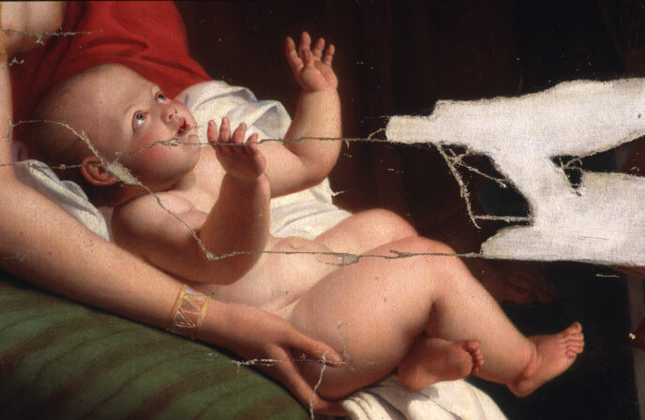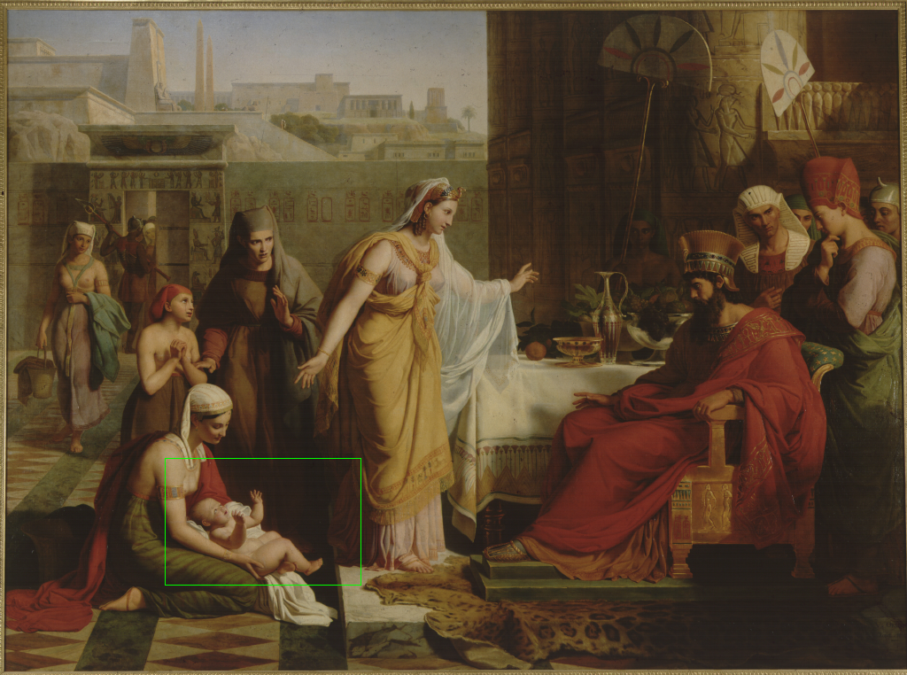

Fig. 2 The image of the baby represents a query, and the result of sub-image matching is shown as a white boundary in the Moise présenté à Pharaon image on the right.

Figure 3 The fax images used in this experiment and their originals.

Figure 4 Fax images and their top six retrieved images

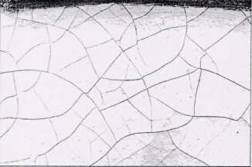
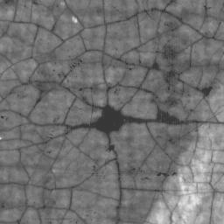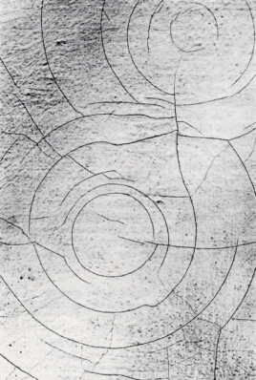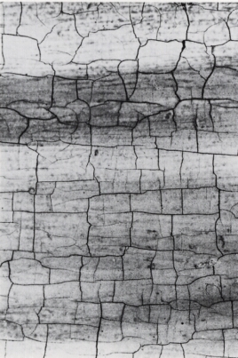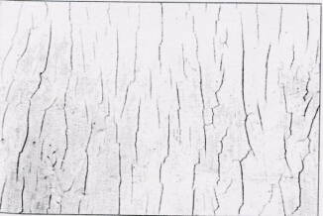

Figure 5 (from left to right, top to bottom)) Crack classes: spider-web, circular, rectangular, unidirectional, random.

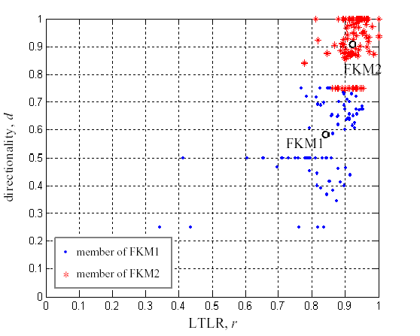
Figure 6: Results of fuzzy K-means clustering of two crack features. FKM1,2 show cluster centres.

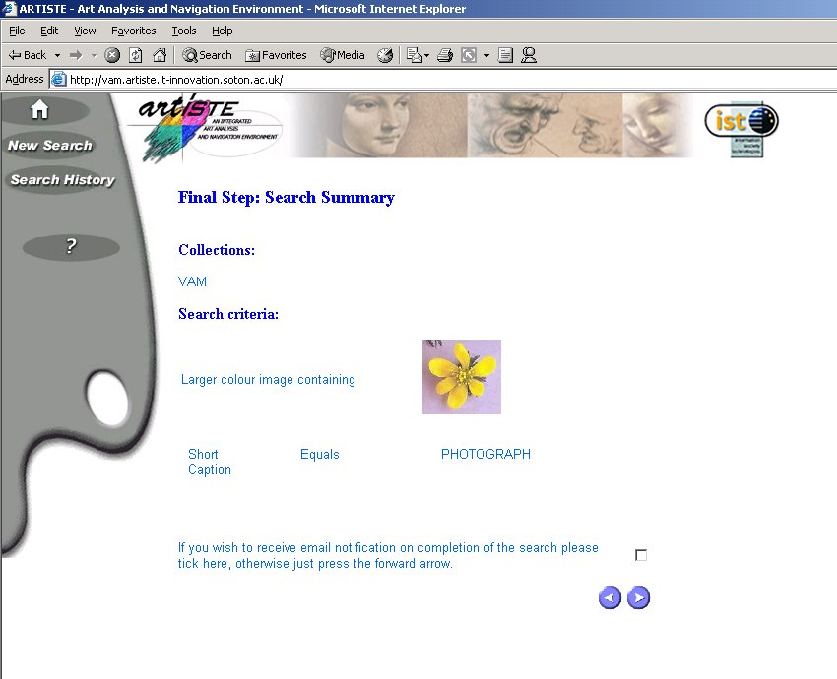
Figure 7 Sample ARTISTE query

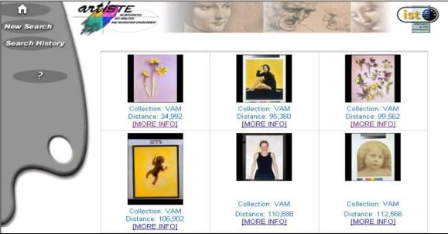
Figure 8 Sample ARTISTE query results
.
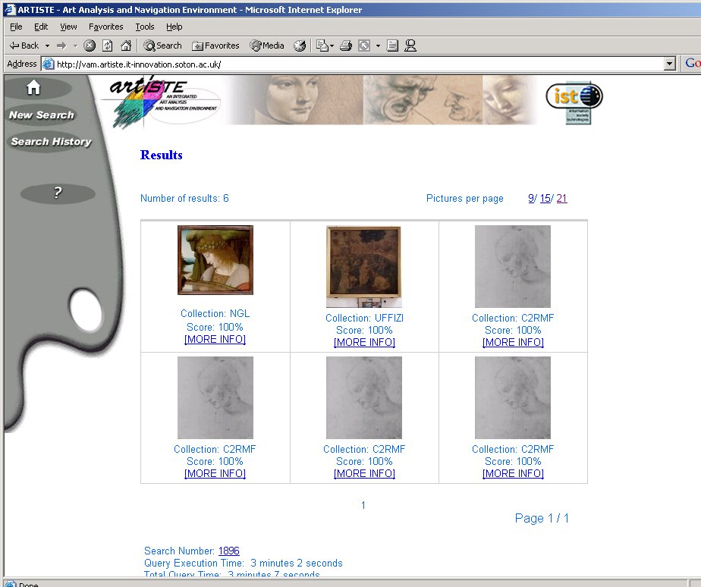
Figure 9 Sample ARTISTE cross collection query results

 Manuscript received January 22, 2003.
 This research was partly financially supported by the European Commission’s Fifth Framework programme, project Artiste.: IST-1999-11978. Server equipment was kindly provided by Hewlett Packard’s Art & Science programme. P. H. Lewis, K. Martinez, F. S .Abas, and M .F. A. Fauzi are with the Electronics and Computer Science Department of the University of Southampton, UK. phone: +44 (0)2380 594491; fax +44 (0)2380592865; e-mail: [phl,km,fsa00r,mfaf00r]@ecs.soton.ac.uk. M. Addis is with the IT Innovation Centre, Southampton, UK. C. Lahanier is with the Centre de Recherche et de Restauration des Musées de France, Paris, France. J. Stevenson is with the Victoria and Albert Museum, London, UK S.C.Y.Chan is with Panasonic, Basingstoke, UK.

