ARTISTE: an Integrated Content and Metadata based Retrieval and Navigation System for Diverse Art Images

P. H. Lewis¹, K. Martinez¹, M. F. A. Fauzi¹, M. Addis⁴, C. Lahanier², J. Stevenson³ +…..
¹Intelligence, Agents and Multimedia Research, Group, University of Southampton, UK
²Centre de Recherche et de Restauration des Musées de France, Paris, France
³Victoria and Albert Museum, London, UK
⁴IT Innovation Centre, Southampton, UK

Abstract

Introduction
The aim of the ARTISTE project was to develop an Integrated Art Analysis and Navigation Environment hosted on a distributed database and accessed via the World Wide Web. The environment includes a range of facilities for searching and analysing digital art images and includes tools not only for retrieval using metadata but also for a wide range of content based retrieval activities. Partners in the collaboration include NCR Systems Engineering Copenhagen, Giunti Interactive Labs, Centre de Reserche et de Restoration des Musées de France at the Louvre, the National Gallery London, the Uffizi in Florence, the University of Southampton and the Victoria and Albert Museum London.

Content-based retrieval of art images has been a continuous challenge even (Vaughan 1991, Holt 1997). There are often weakly defined requirements from real users and common image processing algorithms are often applied and their success measured. (although Norwegian IBM work was specifically on silverware markings??) In Artiste we attempted to target individual retrieval tasks which were provided by our museum partners in order to obtain more satisfactory results. A list of around ten problem areas was initially established through discussions with the museum partners. This included:
- Finding similar images – especially “do you have this image?”
- Searching using synonyms and multilingual vocabulary
- Searches based on the restoration framework (eg cracks, wooden structures)
- Colour-based searches
- Query by sketch
- Find the parent image of a detail
- Query by Faxed images
- (Border?)
Some of these needed new algorithms others could use standard techniques …..??
After a brief overview of the architecture and the general facilities provided by the system, this paper will concentrate on some specific problems for art image retrieval and analysis which identified by the galleries and addressed in the project. These include the problem of retrieval when only a low quality example image is available as the query, retrieval using sub-image as queries, identification and classification of craquelure and UV spot area estimation (DODGY?).

Image processing system architecture
With over 2 Tbytes of images available simply within the consortium scalability was a prime concern. Images accepted into the systems are analysed by algorithms to produce feature vectors which are stored as binary large objects (BLOBS) within the database. During a query, these feature vectors are compared by fast operators which return scores. Although indexing could have produced considerable speed increases in some cases, this was not used in order to concentrate our efforts on algorithm development. All the image processing code was written in C/C++ using the VIPS/ip library developed in past projects (Cupitt and Martinez 1996). NCR’s TOR database provided automatic symmetric parallelism to further speed-up queries.

Sub-image Location
Many content-based image retrieval systems work with whole images and address questions of the form find me images similar to this query. General techniques based on such features as colour distribution, texture, outline shape and spatial colour distribution have been popular in the research literature and in content based retrieval systems but many techniques only work on the complete images, will not allow the query image to be a sub-image of the image to be retrieved and require similarity in image resolution between query and target.
One of our galleries had a specific requirement to be able to retrieve the full image of a parent painting, given a query image which is of a fragment of the full painting (i.e. essentially a sub-image) and the query may have been captured under different capture conditions and possibly at a different stage in the restoration process from the parent. In this section we present an approach to sub-image retrieval for museum collections which include large numbers of very high resolution art images.

Our approach to the sub-image problem has been to divide the database images into a pyramid of image patches, extracting feature vectors for each patch and matching the query feature vectors with each of the feature vectors from database images to find the best match. We have used a patch size of 64 by 64 pixels and not only tile the whole image with such patches but also repeat the process with another set of patches offset horizontally by 32 from the first set, then offset vertically by 32 and finally offset both horizontally and vertically. The resolution of the image is then reduced by a factor of two and the process repeated recursively until the image is approximately tiled by a single patch. In general, global techniques such as the colour histogram are not effective for sub-image matching in their basic form and previous workers have also used the hierarchy approach.

In our approach, for matching based on colour, we use the colour coherence vector (CCV) rather than the basic colour histogram as the representation of the individual image patches as it carries some useful local spatial information. The colour coherence vector records the numbers of coherent and incoherent pixels of each colour in the patch where a coherent pixel is one which belongs to a patch of similar coloured pixels whose relative size is above a certain threshold. In our tests, the query sub-image is also sub-divided into patches and the best match is obtained by combining the CCV match scores. The CCVs are coded for rapid matching and can be compared at an average rate of 265,000 CCVs per second on…...

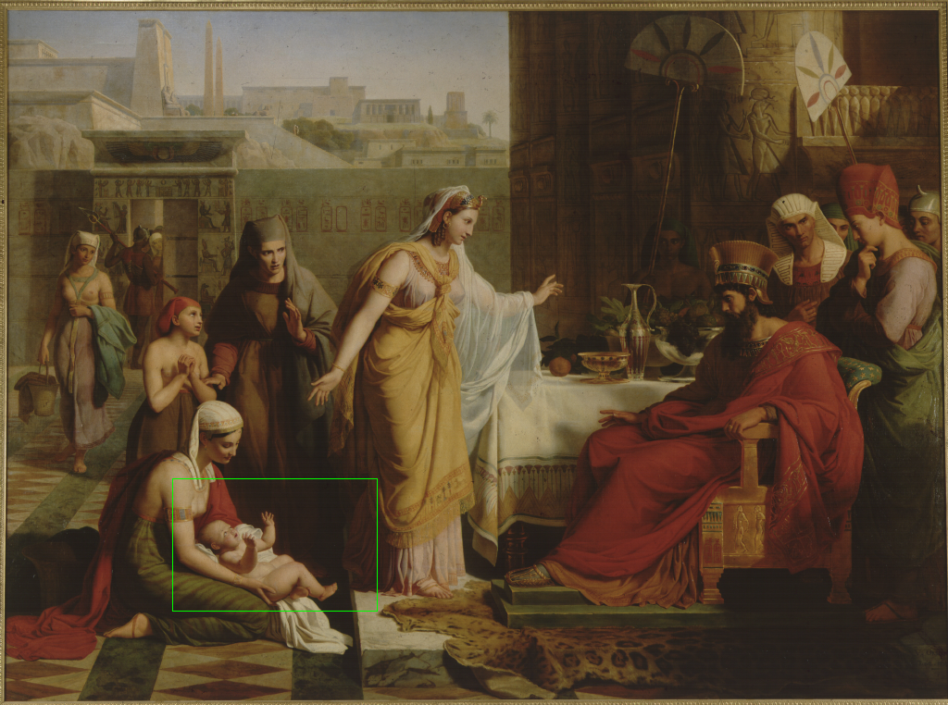
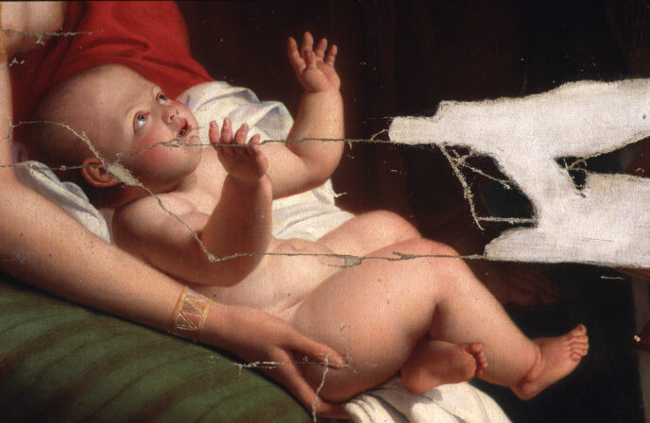
Figure 1. The image of the baby represents a query, and the result of sub-image matching is shown as a white boundary in the Moise présenté à Pharaon image. The rectangular box beneath the query represents the relative size of the query image to the retrieved image.
Query
Retrieved result

Results
In figure 1 we show a query image which is a fragment of the Moise présenté à Pharaon by Orsel Victor captured before restoration work at the Louvre gallery. The best match is shown in the same figure and it can be seen that the best match is with the correct parent image but after restoration. (The before restoration image was not in the database). Note that the position of the match is highlighted, a necessary facility when dealing with ultra high resolution images. This particular parent image is 6328 by 4712 pixels. It should be stressed that the parent image was scanned at 1.47 pixels per mm of the original painting whereas the sub-image query was captured at a quite different resolution, 0.92 pixels per mm. There were over 1000 images in the database varying in size from 440,000 pixels to 30,000,000 pixels and the retrieval process took about 45.8 seconds on a Pentium III 600Mhz PC. No multidimensional indexing has been used so far although it is intended that the process will be accelerated by its introduction.

In figure 2 we show a further example of the multi scale CCV retrieval in action. The query image is a selection from a fabric from the V&A collection and the best retrievals show the parent tapestry and others containing a similar motif to the sub-image query pattern. The retrieval process took 13.74 seconds to complete for the same database.
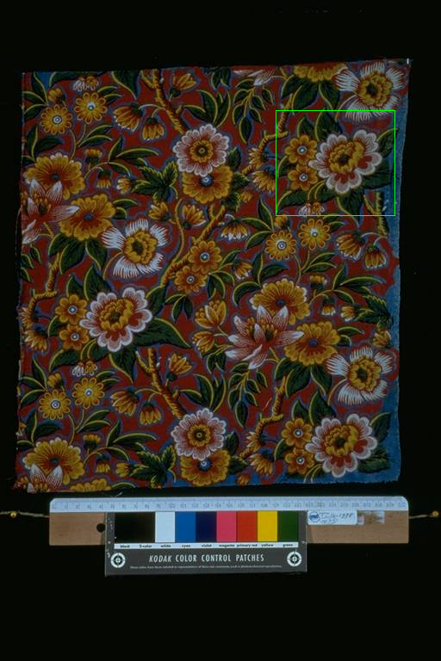

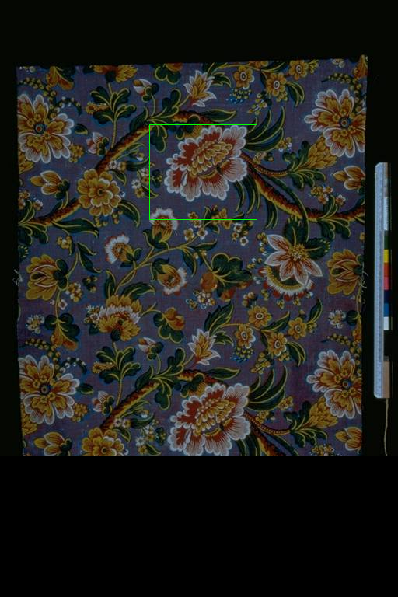
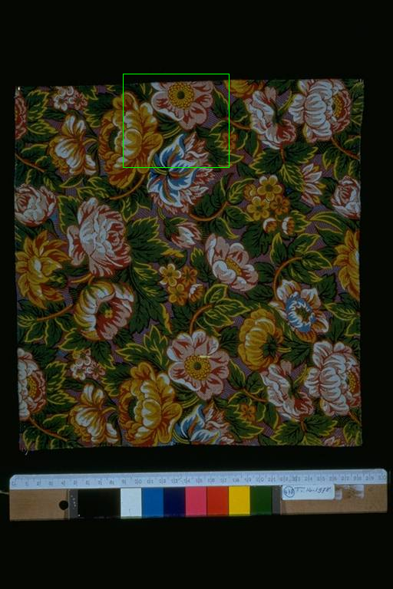

Query
Result 1 (5032)
Result 2 (10784)
Result 3 (11754)
Figure 2. The query image and the top three matches are shown with their respective ranking values.

Conclusions and Future Work
In this paper we have shown that the multi-scale colour coherence vector (M-CCV) technique can provide effective sub-image retrieval and is also applicable when the sub-mage and target are captured at different resolutions. The technique will form part of a battery of content-based retrieval and navigation tools which, together with integrated metadata based retrieval and navigation, will constitute the Artiste art image retrieval and analysis system.
Acknowledgements
The authors are grateful to the European Commission for their support through grant IST-1999-11978 and to their collaborators (NCR (Dk), Giunti Interactive Labs (I), Uffizi Gallery (I), IT Innovation Centre (UK), The National Gallery (UK)) on the ARTISTE project for image data and useful conversations. Thanks also to Hewlett Packard for providing invaluable servers under their Art & Science programme.

References
J. Cupitt and K. Martinez, “VIPS: an image processing system for large images”, Proc. SPIE conference on Imaging Science and Technology, San Jose, Vol. 2663, 1996, pp 19-28

F. S. Abas and K. Martinez, “Craquelure Analysis for Content-Based Retrieval”, Proc. IEEE 14th International Conference on Digital Signal Processing, pp. 111-114, July 2002.
S. Chan, K. Martinez, P. Lewis, C. Lahanier and J. Stevenson, “Handling Sub-Image Queries in Content-Based Retrieval of High Resolution Art Images”, Proc International Cultural Heritage Informatics Meeting, Vol. 2, Sept. 2001. pp.157-163.

M. Westmacott, P. Lewis, K. Martinez, “Using colour pair patches for image retrieval”, Proceedings of the IS&T First European Conference on Colour in Graphics, Imaging and Vision, April 2002, pp. 245-247.

P. Allen and M. Boniface and P. Lewis and K. Martinez, “Interoperability between Multimedia Collections for Content and Metadata-Based Searching”, Online Proceedings of the World Wide Web conference, Hawaii 2002.

[Holt 97] Bonnie Holt and Ken Weiss. The QBIC Project in the Department of Art and Art History at
UC Davis. In The 60th ASIS Annual Meeting 1997, Digital Collections: Implications for users,
Funders, Developers and Maintainers, volume 34, pages 189-195. ASIS, 1997.
[Matas 2000] J. Matas, D. Koubaroulis, and J. Kittler. Colour Image Retrieval and Object Recognition Using
Multimodal Neighbourhood Signature. In D. Vernon, editor, Proceedings of the European
Conference on Computer Vision, LNCS volume 1842, pages 48-64, Berlin, German, June
2000. Springer.
[Pass 96] Greg Pass, Ramin Zabih, and Justin Miller. Comparing Images Using Color
Coherence Vectors. In MultiMedia, pages 65-73. ACM, 1996.
[Smeulders 2000] Arnold W. M. Smeulders, Marcel Worring, Simone Santini, Amarnath Gupta, and Ramesh
Jain. Content-Based Image Retrieval at the End of the Early Years. In Transactions On Pattern
Analysis And Machine Intelligence, volume 22 of 12, pages 1349-1380. IEEE, December
2000.
[Swain 91] M. J. Swain and D. H. Ballard. Color Indexing. International Journal of Computer Vision,
7(1):11-32, 1991.
[Vaughan 91] W. Vaughan. “Automated Picture referencing; Another look at Morelli” in Computers
and the History of Art, Vol. 2 (1991), no. 2, pp.7 -18. [Harwood Academic Publishers ISSN 1048 - 6798]

Several extensive general reviews of content-based image retrieval techniques have appeared in recent years (Smeulders 2000). CBR has been applied to Art images since the 1980s with the Morelli project (Vaughan 91) and IBM's QBIC for example has been applied to such images in a collaboration with UC-Davis (Holt 97). Previous approaches usually applied a generic CBR system to a group of Art images to see how useful it would be. In Artiste we aim to solve specific CBR problems in this way rather than producing a generic solution for all queries.
Use of the colour histogram (Swain-91) for comparing images has been popular primarily because it is easy to compute, is fairly insensitive to small variations between images and is relatively efficient in terms of computation speed and storage requirements. It has the disadvantage that it does not capture any information about the distribution of the colours spatially within the image and various techniques to capture such information have been proposed including the colour coherence vector approach (Pass-96).

COMMENTS WHICH COULD BE ADDED?
Some queries required a precise result – such as a counting features, others such as sub-image location did not have to be very precise, and some such as colour retrieval could be imprecise as long as similar images were in the top scores so that the user could make the final choice. So some results were stored permanently in the database as new metadata (eg shape of painting border) while others produced a score.

