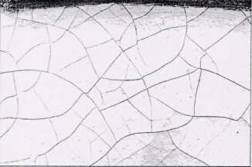
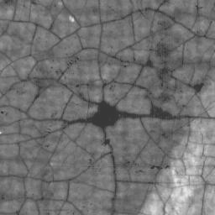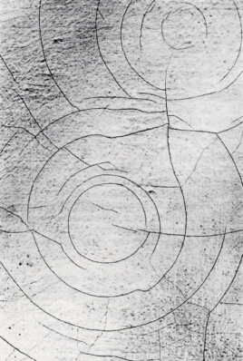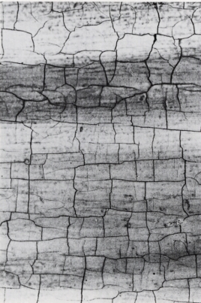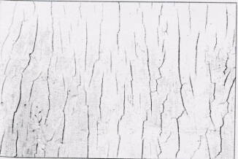

Figure 6 (from left to right) Crack classes: spider-web, circular, rectangular, unidirectional, random.

Figure 1 ARTISTE system architecture

Figure 2 The image of the baby represents a query, and the result of sub-image matching is shown as a white boundary in the Moise présenté à Pharaon image on the right.

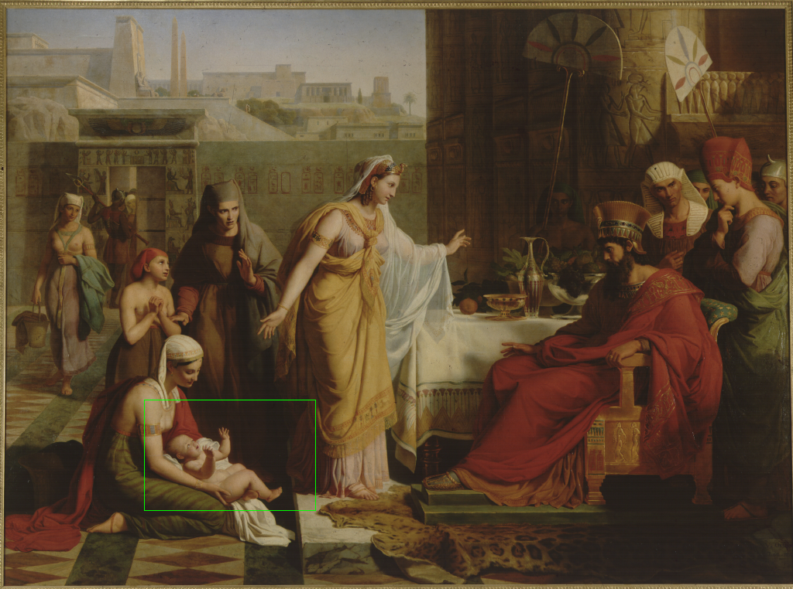

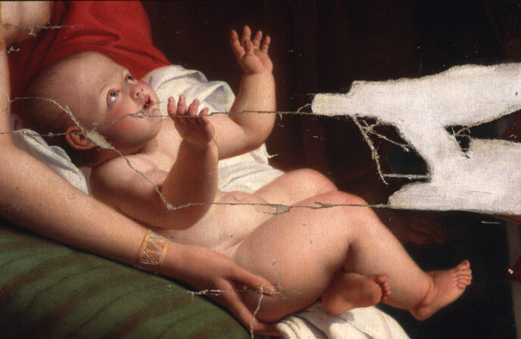

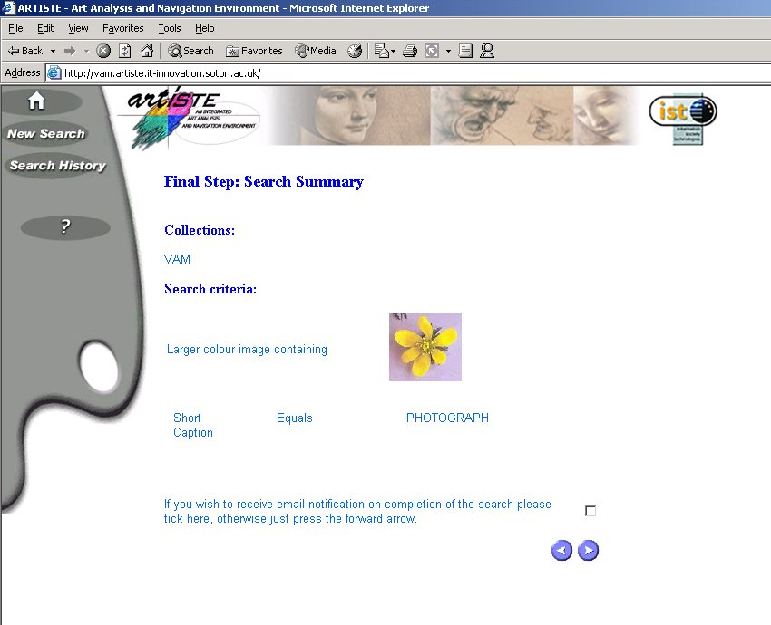

Figure 8 Sample ARTISTE query

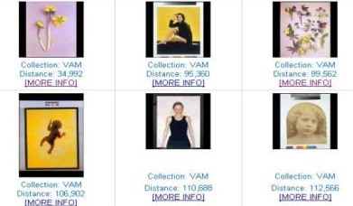

Figure 9 Sample ARTISTE query results

