

Code of Conduct
School of Physics and Astronomy

→ We are resolute in our commitment to provide a supportive environment in which we value differences, respect diversity and treat each other with equity and respect.
→ We ensure individuals are treated equitably regardless of gender and gender identity/ expression, ethnicity, religion, nationality, sexual orientation, race, physical appearance, age or disability.
→ We do not condone or tolerate intimidating behaviour, including harassment (verbal, non- verbal or physical), bullying or victimisation.
→ We collaboratively preserve a community in which positive working relationships are forged and everyone feels valued, encouraged and supported.
→ We strive to maintain an environment free of inappropriate or offensive language or behaviour, where individuals consider their own behaviour and the impact that this can have on others.
→ We are dedicated to fostering a culture that empowers all members of our community to act promptly to challenge unacceptable behaviour.
→ We provide support to staff, students and visitors who feel they have been subjected to, or have witnessed, harassment, bullying or victimisation.
→ We ensure that allegations of harassment, bullying or victimisation are addressed fairly, with respect for the rights and dignity of all those involved.
→ Every member of the P&A community is committed to playing an active role in creating and maintaining an environment that does not tolerate harassment, bullying and victimisation.

Together we can continue to ensure Physics and Astronomy is an outstanding and inclusive place to work and study.

“The time is always right to do what is right.”
Martin Luther King, Jr
If you have experienced or witnessed abuse, bullying, or harassment at work or study, the university Harassment Contacts can offer support, and guidance for further action: www.southampton.ac.uk/hc
H
C
R
E
D
N
E
G
U
C
E
R
E
T
R
A
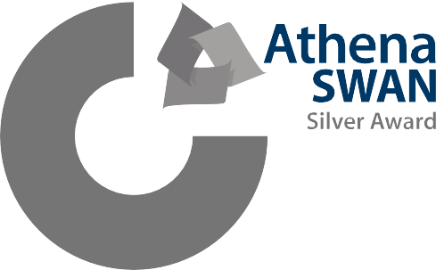
For further information please read the University Dignity and Work and Study policy, Embedding Collegiality and Whistleblower policy.









