**University of**

\l)Southampton

**Membership of Council and Related Bodies: Register of Interests**

**In accordance with Council Standing Orders, members of Council and all those persons described as "Lay Members" for this purpose are required to make a declaration of their interests.**

Please complete this form with respectto your own financial and non-financial interests (and those of your close family, spouse or partners so far as is known to you) and return by email to Rosanna Newey [(R.E.Newey@soton.ac.uk).](mailto:(R.E.Newey@soton.ac.uk) Please complete ALL sections. "Not applicable" should be used where appropriate. Please submit all information on this form only; additional documentation will not be accepted. (Note: the boxes below will expand as you type.)

This form will be held electronicallyon University systems and published for publie view to the website ([www.southampton.ac.uk).](http://www.southampton.ac.uk/)

You will be contacted annually via email andasked for anyamendmentsoryour confirmation that there are no changes. These emails will also be kept on University systems by way of your signature.

|  |  |
| --- | --- |
| Member's name: | Judith Macgregor |
| Member's position: | Vice-Chair of Council |

Former British Diplomat. Retired with a Civil Service pension on 31 March 2017.

1. Remunerated employment, office profession, etc.

2. Remunerated directorships, consultancies. trusteeships, paid appointments to public office etc.

Independent board member Fresnillo pie



None.

3. Si!mificant shareholdin_gs amountin_g to 5% or more of the share issue

My house (owned freehold) lies within a mile of the university.

Board Member, British Tourist Association; Chair, International Strategic Advisory Group to UKRI; Member Arts and Humanities Research Council; Member of University of Cape Town Trust; Deputy Lieutenant, Hampshire; Honorary Bencher Middle Temple, Trustee Ca radon Lecture Charity Trust.

5. Current non-financial interests such as governorships and membership of public bodies, trusteeships and unremunerated directorships, trusteeships of charities*, membership of the freemasons or other secret society, etc.

* Under the terms of the Financial Memorandum July 2010the University is required to publish on its website' A list of all other charities (if any) of which each trustee (i.e. Council member) is then also a trustee' (Model Financial Memorandum between HEFCE and institution Annex H - Information requirements for HEis that are exempt charities).

**E-SIGNATURE:** Please add an electronic signature or insert a .jpeg or .bmp image of your signature.

*:*

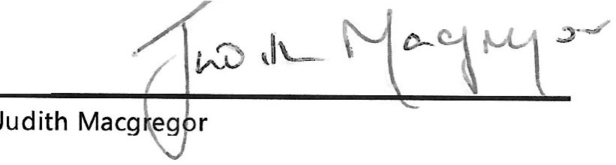

**X**

Date: Click or tap to enter a date. *\C:* . C) • *z_(.-*

Please save this as a Word document (.doc or .docx) and email to [R.E.Newey@Soton.ac.uk](mailto:R.E.Newey@Soton.ac.uk)