ESRC IAA – Missions Call Guidance - 2025

Background
The Labour Party campaigned on a platform of ‘Mission Led Government’ and now seeks to govern by it. Based on the theoretical framework developed by UCL’s Mariana Mazzucato, ‘Mission Led’ has been interpreted by Labour as the setting of five priority policy areas (see fig 1), which will be achieved by a series of supporting policy goals. This represents a departure from a departmental to a cross-government (XG) approach, working together to achieve the ‘Mission.’ With the outcome of the Spending Review (SR) imminent the civil service has turned its attention to how it will operationalise Mission Led government at a micro level with the development and planned evaluation of XG interventions using allocations from the SR.
There is currently a significant lack of clarity about how this transformation will be delivered, coupled with a recognition of the urgency and importance the administration places on making meaningful progress towards achieving Missions during this Parliament. Civil servants will be seeking timely, accessible and robust evidence for policy development and instruments to measure progress towards policy priorities and goals.

This provides a unique opportunity for up to 5 researchers to engage government with evidence relevant to achieving policy priorities and goals in 2025 (the window of opportunity is until September 2025) and potentially enabling researchers to achieve policy impact for REF2029. This call funded by the university’s Impact Acceleration Accounts (IAA) and led by Public Policy Southampton, is to help shape and inform civil service thinking with robust, impartial research evidence during this time.

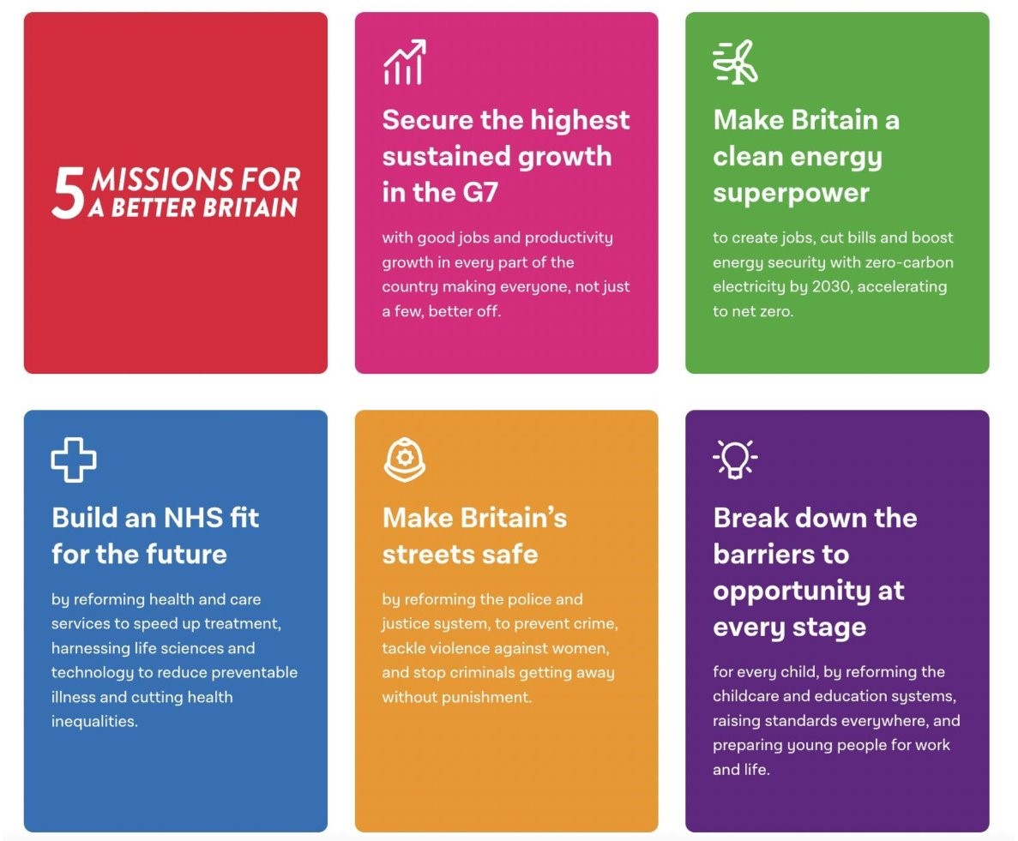
Figure 1 Labour’s five Missions for government

Expected use of funds
Applications must clearly articulate which Mission and policy goal their research addresses and provide details on how they intend to utilise this funding to package their findings to share with government. The background research does not need to have been ESRC-funded and applications are welcome from members of any department or faculty at the University of Southampton. Applications must have an academic PI but activities can be supported by postdoctoral researchers and/or doctoral students at the end of their studies, for collation of the research evidence in to briefing packs, slide decks and executive summaries, and support for the academic lead to attend knowledge exchange events to engage with civil servants.

All requests for funding need to be clearly justified. IAA funding cannot be used for new research activity, website development costs, any PC/ computer equipment, software including iPads/tablets, attendance at academic conferences or seminars with no clear KE component, indirect costs and estate costs, standard ineligible ESRC grant costs, consultancy fees/external costs that exceed 50% of overall funding request.

Application criteria
- Funding of up to a value of £5k can be requested
- Projects are to commence on Monday 2nd June 2025 with a maximum duration of 3 months (expected end date by Friday 31st August 2025)
- The following costs, if included, will need to be accurate, clearly identified and justified:
  - UK travel (who, where, when, how)

How to apply
Applications are to be submitted to the IAA Team in Research and Innovation Services (impact@soton.ac.uk). Applications to be received no later than 11.59pm Wednesday 7th May 2025.

Timeline

Missions Call information session | 22nd April 2025
Application deadline: | 7th May 2025
Anticipated outcome date: | 21st May 2025
Project start date: | 2 June 2025
Projects end date: | 31st August 2025
Final reports due: | 30th September 2025

Contacts
If you have any questions, please do not hesitate to contact either the Public Policy Southampton team (publicpolicy@soton.ac.uk) or IAA team (impact@soton.ac.uk) using ‘Missions IAA call’ in the subject line.

ESRC IAA – Missions (2025) Call Application Form

Section A: Applicant Details

PI name & contact details:

Co-applicants:
Faculty, School & Dept:
Project Title:
Start Date & Duration | 2nd June 2025 – 31st August 2025 (3 Months)
Funding requested | £

Section B: Project Details
Mission(s) and sub goal (e.g. Mission 1 Growth, 1.5m new houses)

Brief project description (e.g. motivation, research being exploited, fit with mission objectives)

Description of activity (please limit to approximately 500 words)
Please explain how you will use the funding and the proposed activities
Deliverables

Section C: Costs and Funding
Source | Amount (£)
Amount requested from ESRC IAA & breakdown of major categories/items | Total: £
In kind contributions (list activities and estimate the value)

This must include the PI’s time on the project, all estates, and indirect costs at least (details of which can be obtained from faculty finance)
Detailed breakdown and justification of above costs including staff, consumables and travel costs.

