TNMundi in Madagascar - November 2007
“Musics of Madagascar : South < > North Crossroads?”
International Conference and Cultural Event
Antananarivo, November 15-17, 2007
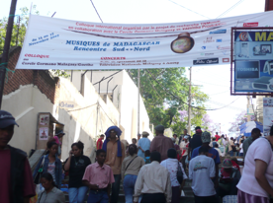

A collaboration between the TNMundi project (AHRC/University of Southampton/University of Aberdeen-United Kingdom), the Cercle Germano-Malagasy (Madagascar) and Vazimba Produktion (Madagascar), this two–day event offered a new perspective on the relations between North and South, or more particularly between Madagascar and Europe, by focusing on the role of artists and their music within transnational networks. It challenged the more usual focus on artistic and cultural flows from the South to the North and on cosmopolitan European cities as centres of creativity, by redirecting our attention to the pivotal role which the South itself plays as magnet, inspiration and melting pot for social and cultural influences and flows. Framing our enquiry through our title question suggested a multiplicity of interconnections, with Antananarivo positioned as a hub for movements of musicians and cultural expressions between south and south, south and north, north and south. It also suggested an agenda for exploring a whole range of interconnecting themes across the spectrum of political, social, legal, economic and environmental concerns in the relationship between Madagascar and Malagasy people living in Europe.

Conference at the Cercle Germano-Malagasy, Antananarivo
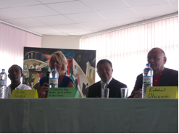
Conference Opening
From l. to r.: Dama (Artist-TNMundi), Ulrike Meinhof (University of Southampton-TNMundi), Patrick Ramiaramanana (Ministre des Sports, de la Culture et des Loisirs), Eckehart Olszowski (Cercle Germano-Malagasy).
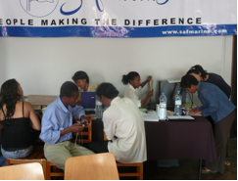
Volunteers’ team in the Cercle Germano-Malagasy
From l. to r.: ---, Jao Arsène, Tsiky, Miary, Ludonie (Students University of Antananarivo), Narindra, Felana Ericah (volunteers in Vazimba Produktion)
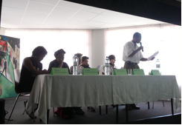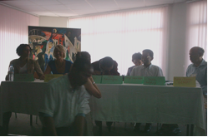
*(Left) Panel “South-North relations: Malagasy artists in Madagascar and Europe”
From l. to r.: Donné Randriamanantena, Sammy Andriamalalaharijaoa, Mfa Kera, Justin Vali, Edgard Ravahatra, Dama.
*(Right) Panel “Researching Artists’ Networks”
From l. to r.: Nadia Kiwan (University of Aberdeen, United Kingdom), Ulrike Meinhof (University of Southampton, UK), (standing and hidden: Marie-Pierre Gibert (University of Southampton, UK)), Rafolo Andrianaivoarivony (Université d’Antananarivo), Bako Rasoarifetra (Université d’Antananarivo), Serge Rodin (Université d’Antananarivo), Taieb Belghazi (Université Mohammed V, Maroc).

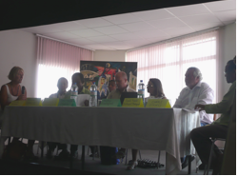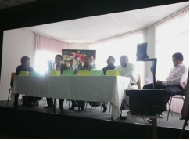
*(Left) Panel “Music and Civil Society: Artists-NGOs collaborations”
From l. to r.: Ulrike Meinhof, Anicet Randriantsalama (Comité National de lutte contre le Sida), Dama (Voajanahari), Brett Massoud (Azafady), Sophie Goedefroit (Université Paris 5-CNRS), Erich Raab (Freunde Madagaskars); Charles Bert Andrianaivo (CICAFE).
*(Right) Panel “The Music Industry – local, national and international”
From l. to r.: Hemerson Andrianetrazafy (Université d’Antananarivo), Dama, Rakotoarison Henri (Responsable partenariat et promotion PME au Ministère du commerce et de l’industrie), Rakoto (Douanes), Haja Ranjarivo (Office Malgache des Droits d’Auteurs), Belanto (journaliste), Jaobarison (Média Consulting).

Concerts, Télévision Nationale Malagasy (TVM), Antananarivo
In addition, privileging practice-oriented research, this symposium was also viewed as an opportunity to strengthen networks of all constituencies involved and act as a catalyst for further activities. Therefore, in collaboration with Vazimba Produktion, the event also gave rise to two original concerts on the night of the 15th and 16th November at the Auditorium de la Télévision Nationale Malagasy (TVM) in Antananarivo, with celebrated artists of Malagasy origin from within Madagascar and from Europe: Justin Vali, Edgard Ravahatra, Mfa Kera & Reinhard Katemann, Marius Fontaine, Rachel Ratsizafy, Dama, Ricky, Jaojaoby, Donné Randrimanantena, Hajazz, Baba de Madagascar, Masy & Mony Bertin Mahatsinjy, Tiana, accompanied by Berra and Tina.
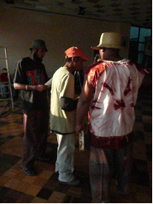
Part of the Vazimba Produktion’s team during concerts’ rehearsals.
From l. to r.: Solofo, Rinah, Ricky (unfortunately, neither Irina nor Lova are on the picture)

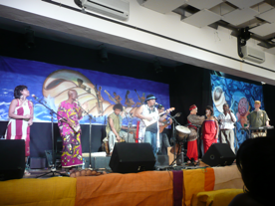
From r. to l.: Reinhard (keyboard), Dama (chorus), Rachel (chorus), Mfa Kera (chorus), Olivier (guitar), Marius (kabosy & lead singer), Donné (percussion), Mony (chorus et karataka), Tina (chorus).
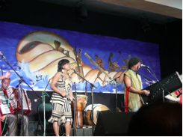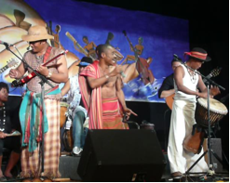
*(Left) - Tina (accordeon), Tiana (lead singer), Donné (marovany).
* (Right) - Claudine, Hajazz (guitar), Marius (percussions), Jaojoby (lead singer), Olivier (guitar), Baba (djumbe).

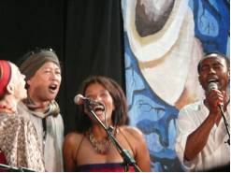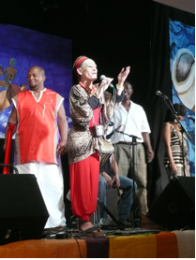
*(Left) - Mfa Kera, Edgard, Rachel, Dama
*(Right) - Ricky, Mfa Kera, Dama, Tina

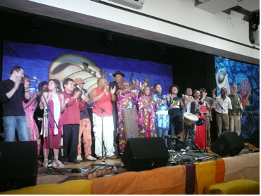
All the artists: from l. to r.: Olivier-Roman Garcia, Jaojoby, Claudine Jaojoby, Tiana, Justin Vali, Venga, Ricky, Baba de Madagascar, Mony Bertin Mahatsinjy, Masy, Berra, Donné Randriamanantena, Marius Fontaine, Mfa Kera, Edgard Ravahatra, Dama, Reinhard Katemann.

