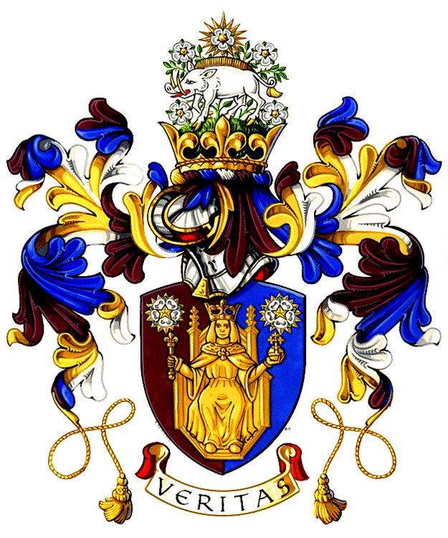
The Richard III Foundation, Inc.

Presents
Yorkists and Lancastrians: In Armour and Blood

Our symposium will be held on Saturday, October 15 at the Dixie Grammar School in Market Bosworth. Registration begins at 8:30. The conference will begin at 9:00 am and will conclude at 5:00 pm. Our speakers and topics are:

- Professor Anne Curry - Military Career and Armies in the Wars of the Roses
- Professor Matthew Strickland - Warfare in Mid 15th Century France and Burgundy
- Dr. Tim Sutherland - Cannons, Arrowheads and Mass Graves: Towton - Archaeological Evidence of Britain's Bloodiest Battle
- Peter Algar - Hot Coals of Vengeance! A foray into the ill-famed family of Cliffords.
- Mark Stretton - The Power and Effectiveness of the Warbow in Battles
- John Sadler - The Anglo-Scottish War of 1482.
- Michael Miller – The Man Who Would Be King
- Our special introduction by the Foundation’s honorary patron - Robert Hardy, CBE. “A Towton Tale” by the late John Davey - narrated and acted by John Pilkington.

 | Number of Tickets
Symposium (package for Saturday’s event and membership fee to the Foundation for one year) Note: this package is not for current patrons of the Foundation. |  | £43.00
Symposium (Saturday only) |  | £35.00
Symposium (ticket sold at the door on Saturday) |  | £45.00
I enclose a cheque for full amount |  | £
Please print your details clearly. Note there are no refunds and tickets are not transferable.
Full Name:

Address:

Postcode: | Telephone:
Email Address:
Guest Full Name:

Address:

Postcode: | Telephone:
Email Address:

How did you learn of conference

To reserve your seat, please mail your registration form along with your check payable to “The Richard III Foundation, Inc.” to The Richard III Foundation, Ms. Dorothy Davies, Half Moon House, 32 Church Lane, Ryde. Isle of Wight PO33 2NB. For further questions, please email us at Richard3Foundation@yahoo.com. Website: www.richard111.com.

